HWA CHONG INSTITUTION
2010 C2 Higher 2 CHEMISTRY 9647 PRELIMINARY EXAMINATION

PAPER 2 Structured Questions (ANSWERS)

1(a) The addition of 2 C–H bonds and 1 C–C bond.

1(b) Decreasing straight line graph (not necessary to pass through the origin)

1(c) Dependent variable: temperature rise

Controlled variable:
- mass of water used
- distance of flame from the calorimeter

1(d)
- the precision of the apparatus to be used (mention use of measuring cylinder or burette; thermometer precision and precision of balance).
- the way in which the independent variable is varied between experiments (change sample of alcohol and weighing of alcohol).
- measurements of the dependent variable (initial and final temperature of water).
- appropriate quantities to be used (volume of water and volume of alcohol).
- Correct general approach (weighing of alcohols and taking temperature rise of water in calorimeter).

Processing of raw data
Mass of calorimeter = m₁ g
Mass of spirit lamp before combustion = m₂ g
Mass of spirit lamp after combustion = m₃ g
Mass of ethanol used for combustion = (m₂−m₃) g
Initial temperature of water = t₁ ºC
Final temperature of water = t₂ ºC
Qty of heat produced in combustion = [50 × 4.2 × (t₂ – t₁) + m₁ × 0.385 × (t₂ – t₁)] J

∆H_{c} = | 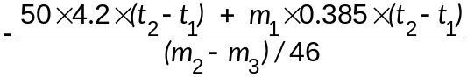 | J mol⁻¹

1(e) Mass of calorimeter = m₁ g
Alcohol | Mass of spirit lamp before combustion m₂(g) | Mass of spirit lamp after combustion  m₃(g) | Initial temp. of water  t₁(ºC) | Final temp. of water  t₂(ºC) | ∆H_{c}  (J mol⁻¹)
methanol
ethanol
propan-1-ol
butan-1-ol
pentan-1-ol

1(f)(i)
- Alcohol is volatile and toxic.
- Alcohol is flammable and may cause a fire if ignited accidentally.

(ii)
- Containers of alcohols should be covered when not in use; proper disposal of alcohols.
- Start the fire to burn the wick away from other alcohols.

2(a)(i) Copper: cation / Cu²⁺ ion
metallic bonding

2(a)(ii) Iodine: molecule
van der Waals’ forces / dispersion forces / id-id interactions

2(b) The sea of delocalised electrons is able to accommodate any deformation to the cationic lattice OR The layers of cations can slide past each other while electrons hold them together.

2(c) Electrical conductivity / solubility in organic solvent

Conductivity: Mobile electrons available to conduct electricity in copper but no mobile electrons or ions in iodine.
Solubility: Similar intermolecular forces of attraction for iodine and organic solvent, thus iodine is able to form favourable interactions with the organic solvent, but copper is unable to form favourable interactions with the organic solvent.

2(d)(i) Atomic mass is the weighted average of the mass of the isotopes

2(d)(ii) Percentage abundance of the isotopes in this sample differs from what is normally obtained OR There are more than 2 types of isotopes of copper.

2(e)(i) Correct direction and angle of deflection.

2(e)(ii) 1.7º

3(a)(i) Ammonia exerts strong Intermolecular forces (hydrogen bonding) between the gas molecules. (Do not accept large size of molecules as pressure is 1 atm)

3(a)(ii) Molecules of ammonia will not be close enough above 133 ºC as the kinetic energy of molecules are very high; short range intermolecular forces will not operate.

3(b)(i) The equilibrium sign suggest an incomplete ionisation, thus a weak acid.

3(b)(ii) 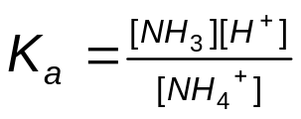

3(b)(iii) 5.62 × 10⁻¹⁰ = [H⁺]² / (0.30– x)
[H⁺] = 1.298 × 10⁻⁵ mol dm⁻³
pH = 4.89
Assumption: Ammonium ion is a weak acid and amount dissociated is negligible.

3(b)(iv) The weak base-strong acid titration has equivalence point at the acidic range from the hydrolysis of the ammonium ion / pKin value is the pH value the indicator changes color.
{pH = pKin ±1}

Thus the correct indicator is bromocresol green.

3(c)(i) K: CH₃CH₂NH₃⁺CH₃CO₂– L: CH₃CH₂NHCOCH₃

3(c)(ii) J: (CH₃CH₂)₄N⁺Br–

3(d) Correct ranking:

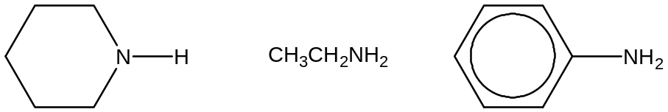

C₅H₁₀NH is more basic than CH₃CH₂NH₂ as it has more electron-donating alkyl groups, thus increasing the availability of lone pair of electrons on N for acid-base reaction.

Phenylamine is the least basic because the lone pair of electrons on N is delocalized into the benzene ring so less available for acid-base reaction.

4(a) Cr(s) + 3H⁺(aq) → Cr³⁺(aq) +3/2H₂(g)
OR Combustion: 2Cr(s) + 3/2O₂(g) → Cr₂O₃(s)

4(b)(i) [CrCl(H₂O)₅]Cl₂.H₂O
[Cr(H₂O)₆]Cl₃
[CrCl₃(H₂O)₃].3H₂O

4(b)(ii) A solution of Cr³⁺ is acidic in nature due to the high charge density of the cation.
[Cr(H₂O)₆]³⁺(aq) + H₂O(l)  [Cr(OH)(H₂O)₅]²⁺(aq) + H₃O⁺(aq)

4(b)(iii) chromium(III) hydroxide OR Cr(OH)₃ OR [Cr(OH)₃(H₂O)₃]

4(b)(iv) [Cr(NH₃)₆]³⁺

4(b)(v) Ligand exchange has occurred. Different ligands cause different energy gaps, which correspond to different wavelengths of visible light being absorbed. Hence different colours are observed.

4(c) 1st colour change: Cr₂O₇²⁻ (orange) → Cr³⁺ (green) E = +1.33 – (–0.76) = +2.09 V
2nd colour change: Cr³⁺ (green) → Cr²⁺ (blue) E = –0.41 – (–0.76) = +0.35 V
3rd colour change: Cr²⁺ (blue) → Cr³⁺ (green) (oxidation by air in acidic medium)
E = +1.23 – (–0.41) = +1.64 V
OR Cr²⁺ (blue) → Cr³⁺ (green) (oxidation by H⁺ in absence of air)
E = +0.00 – (–0.41) = +0.41 V

5(a)(i) t_{1/2} is constant ~3min.
Reaction is first order wrt aqueous sodium hydroxide.

5(a)(ii) When concentration of the bromoethane double, the gradient of the graph doubles.
Therefore reaction is first order wrt to the bromoethane.

5(a)(iii) Rate = k[C₂H₅Br][OH–]

5(b)(i) Name: Nucleophilic substitution, S_{N}2
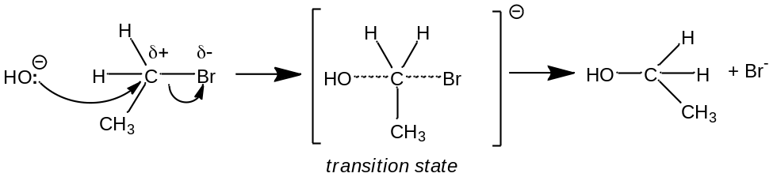

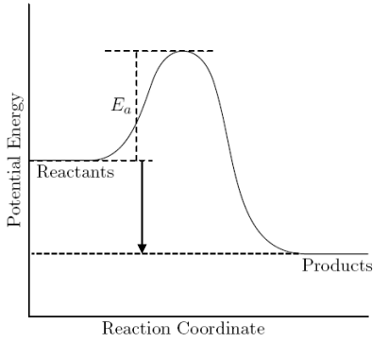
5(b)(ii)
ΔH
Transition State
Energy
Progress of Reaction

5(b)(iii) Iodoethane has a faster rate of hydrolysis.
Iodine is bigger hence the C–I bond is longer and therefore weaker.
6(a)(i)
T | 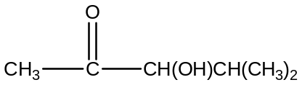
W | 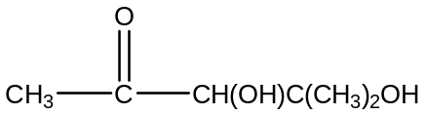
X | 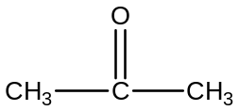
 |  | 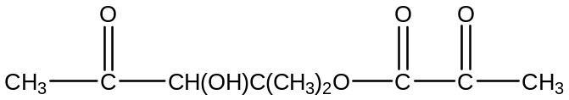
Z | OR | 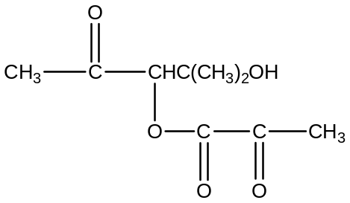
 | OR | 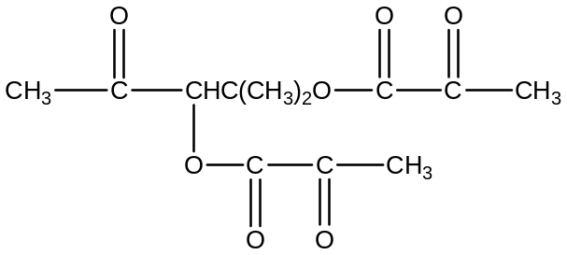

6(a)(ii) Step I: Cl₂(g)
Step II: aqueous NaOH, warm
Step III: KMnO₄/H⁺, warm

6(b)(i) Secondary alcohol and ketone

6(b)(ii) E.g. use Br₂(aq), PCl₅ etc

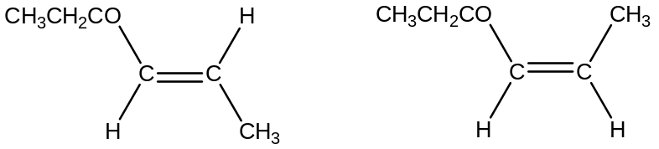6(c)

